# **OBJECTIVES**

The Women and Math Mentoring Program’s **objectives** are to:

* Expand students’ awareness of mathematics- and science-related careers,
* Increase students’ self-confidence in mathematics,
* Develop students’ appreciation for mathematics,
* Encourage students to take challenging mathematics courses in high school and to participate in summer enrichment programs in science and mathematics,
* Develop students’ skills in communicating and collaborating, and
* Foster knowledge-sharing relationships between adult women and young women with common interests.





PROGRAM ACTIVITIES

Students and mentors participate in the following activities:

* **Program Kick-Off Night**, where mentors meet students and their parents and learn about the upcoming program activities;
* A **visit to the mentor’s workplace**, followed by lunch or a snack;
* **Math and Computer Science Career Awareness Day** at North Carolina Central University for students and mentors (***Marjorie Lee Browne Day***), which includes a keynote speech, workshops conducted by women employed in math-related careers in the Triangle, a mentor coffee hour, panel discussions by mentors on careers, lunch, and a math competition with prizes;
* **Informal mentor-student discussions** on future mathematics coursework, summer enrichment programs, and possible careers;
* **Field trips** to mathematics-related places of interest such as The Virtual Reality Lab at UNC-CH, the Primate Center in Durham, or the annual Engineering Fair;
* An optional **mentor-guided group project** involving mathematics, science, and/or computer science;
* A concluding event at NCCU,
* ***M3: Mentoring Madness in May***, for students, mentors, and parents. Students share their mentoring experiences and projects with the whole group. The finale is a big game and puzzle competition with prizes for the winning teams!

TIMELINE 2016-2017

JULY-NOVEMBER:

*Recruitment of mentors*; program planning

SEPTEMBER-OCTOBER

*Students* are chosen for the program

NOVEMBER:

*Mentor Orientation* for all mentors

Saturday, November TBD 8:00-11am

North Carolina Central University

DECEMBER:

*Mentors introduce themselves to students and their parents* by telephone and/or mailed note, and may arrange a time for a January activity

JANUARY:

*Program Kickoff Night*

DPS Staff Development Center

MARCH:

*Marjorie Lee Browne Day*

JANUARY-MAY:

*Monthly activities*: may include a visit to the mentor’s workplace, field trips, group projects, informal group and individual discussions

MAY:

*M3 Mentoring Madness in May*

JUNE:

*Program Evaluation Dinner* for Mentors

PROGRAM PLANNING

Program planning is done by the Women and Math Mentoring Planning Committee, which is led by Tina Ewing, Director, and is made up of women in math-related professions who have been mentoring in the program for many years. The Planning Committee is responsible for:

* Maintaining the relationship with school administrators. Under the supervision of the Durham Public Schools Mathematics Specialist, mathematics teachers and chairs will be asked to nominate six 8th-grade girls from each middle school. Students’ interest and enthusiasm for mathematics and science will be the basis for selection.
* Recruiting mentors and organizing Mentor Orientation. Mentor Orientation will take place on a Saturday morning in November. Mentors will be given training and materials. Using the students’ application forms, they will choose two or three students from the same school. Orientation will end with the formation of Mentor Groups, which link up new mentors with experienced mentors, providing a peer support system.
* Organizing *Program Kick-Off Night*, *Marjorie Lee Browne Day*, and *M3:* Mentoring Madness in May



Any woman interested in being a MATH MENTOR

during the 2015-2016 school year is welcome to contact one of the following members of the Women and Math Mentoring Coordinating Team:

Dr. Laura Smith

WAM Durham County Coordinator

544-6055 coordinator@womenandmathmentoring.org

Ms. Chanel Sidbury

Durham Public Schools Mathematics Coordinator

560-2000 x21315 Tacara.Sidbury@dpsnc.net



*The Math Mentoring Program is funded by , GlaxoSmithKline., Amgen Foundation, Duke University Pratt School of Engineering, and North Carolina Central University. The Program is administered by North Carolina Central University in conjunction with the North Carolina chapter of the Women & Mathematics Network.*

www.WomenandMathMentoring.org

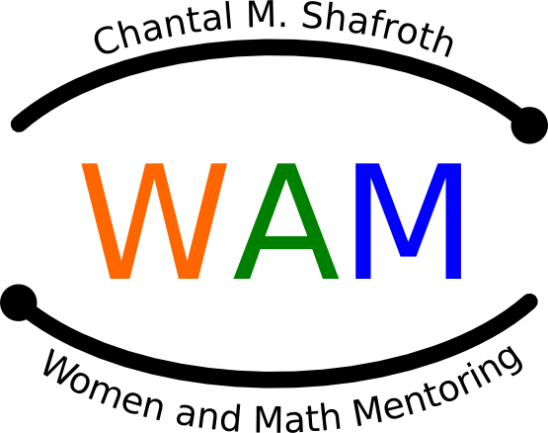

*NC Women and Mathematics Network*

MATHEMATICS MENTORING PROGRAM:

**A BRIDGE TO HIGH SCHOOL**



The **Women and Math Mentoring Program** was created to inspire and encourage **young women** to continue their study of mathematics, and to learn about **careers in which mathematics plays a key role**.

The Program links small groups of **two to three**

**8th-grade girls** with **local female professionals** pursuing **mathematics-related careers**.

Through **monthly interactions** during the spring semester of the school year, the girls learn about their mentor’s job, career and lifestyle.

www.WomenandMathMentoring.org